**GOVERNMENT ARTS COLLEGE FOR WOMEN**

**SALEM-8**

**DEPARTMENT OF MATHEMATICS**

**TEAM ID: NM2023TMID12060**

**TEAM LEAD: M.AKILA**

NM ID: 49BB58764D90C2DAE9740D4DDAB65A46

**TEAM MEMBER 1: ANUSHYA.C**

NM ID: 69F434028EABDC2956A4E88BD3A90944

**TEAM MEMBER 2: BUVANESHWARI.M**

NM ID: 8D5A5E7FFB5ECDF81544B130526F593F

**TEAM MEMBER 3: SOWNDARYA.M**

NM ID: 0B0F1FC0B8802E685C64A28A2697

**BUILD AN EVENT MANAGEMENT SYSTEM**

**USING SALESFORCE**

1. **INTRODUCTION**
   1. **Overview**

**Event management is the process of creating and maintaining an event. This process spans from the very beginning of planning all the way to post-event strategizing. At the start, an event manager makes planning decisions, such as the time, location, and them of their event. That the event requires considerable planning and execution is event management.**

**An event can be described as a public assembly for the purpose of celebration, education, marketing or reunion. It allow the user to select basic functionality required for an event. Event management system is very helpful for events.**

* 1. **Purpose**

**Event management system helps organizers plan, execute and report on event, driving success for their business.**

**The sole purpose of any event is that a group of people will convene in one particular place for one particular purpose at a given time. Events are something that people do regular to ends to coincide with a particular moment in life. Event planning is a fractured market with a lot of independent individual sole proprietors. We want to change that by bringing transparency and trust into the process.**

1. **Problem Definition & Design Thinking**

**2.1 Empathy Map**

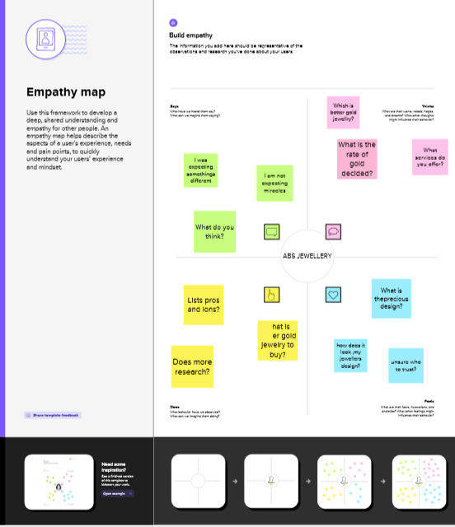

2.2 ***Ideation & Brainstorming map screenshot***

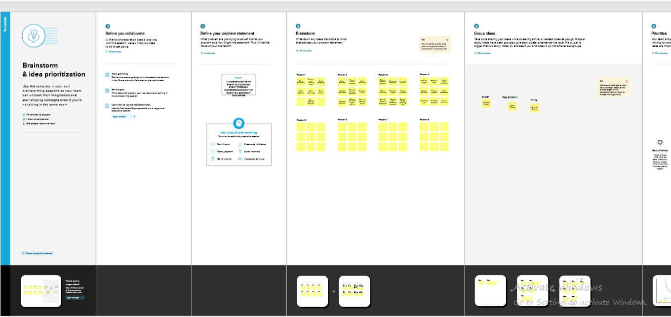

**3. Result**

***3.1 Date Model***

|  |  |  |  |  |  |
| --- | --- | --- | --- | --- | --- |
| ***Event*** | |  |  | | --- | --- | | ***Field label*** | ***Data type*** | | ***City*** | ***Checkbox*** | |
| ***Attendee*** | |  |  | | --- | --- | | ***Field label*** | ***Data type*** | | ***Email*** | ***Email*** | | ***Id*** | ***Auto Number*** | | ***Phone*** | ***Phone*** | |
| ***Speaker*** | |  |  | | --- | --- | | ***Field label*** | ***Data type*** | | ***Bio*** | ***Text Area*** | | ***Event*** | ***Lookup (Event)*** | |
| ***Vendor*** | |  |  | | --- | --- | | ***Field label*** | ***Data type*** | | ***e-mail*** | ***Email*** | | ***Event*** | ***Lookup (Event)*** | | ***phone*** | ***phone*** | |

|  |  |  |  |  |  |  |  |
| --- | --- | --- | --- | --- | --- | --- | --- |
| Student | |  |  | | --- | --- | | Field label | Data type | | Event | Master detail (Event) | | Tickets | Pick list | |

3.2 Activity & Screenshot

*Milestone 1: Creating Developer Account*

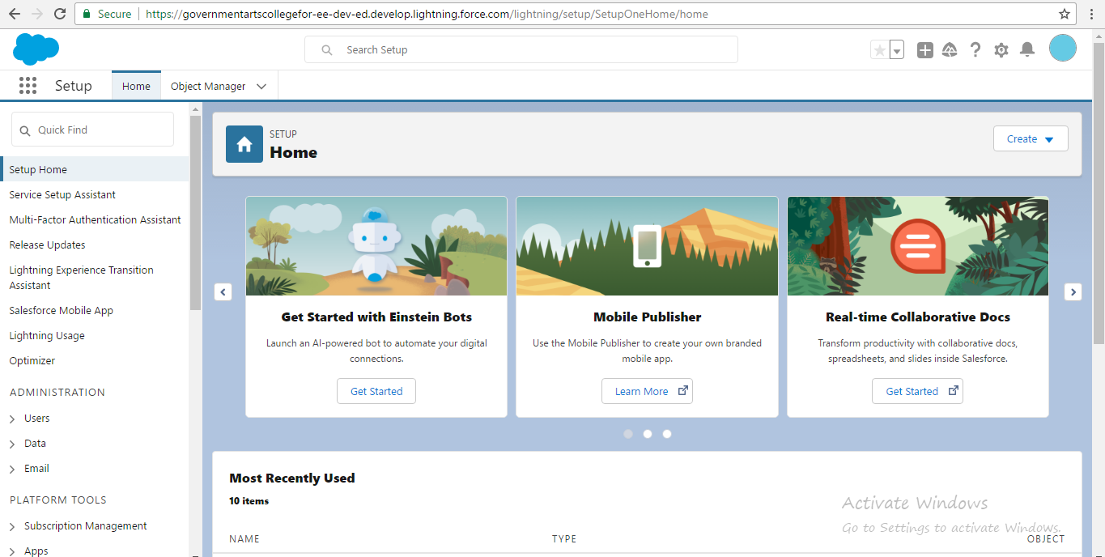

Milestone 2-Tab:

* Click on home tab, enter taps in Quick find and select tabs

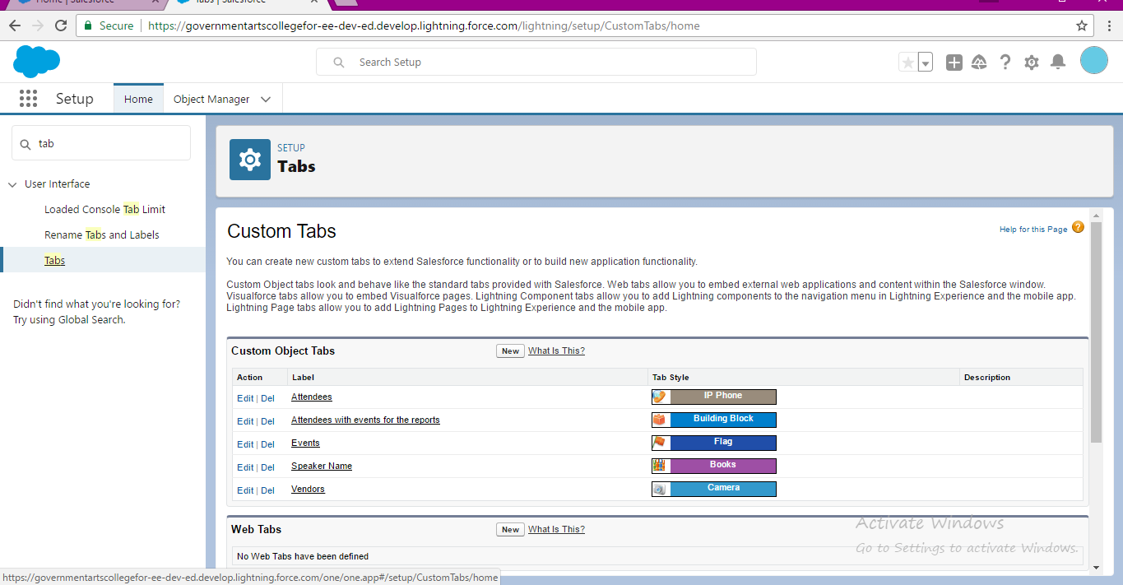

Milestone 3- Application:

* From setup, enter App Manager in the Quick find and select App Manager.

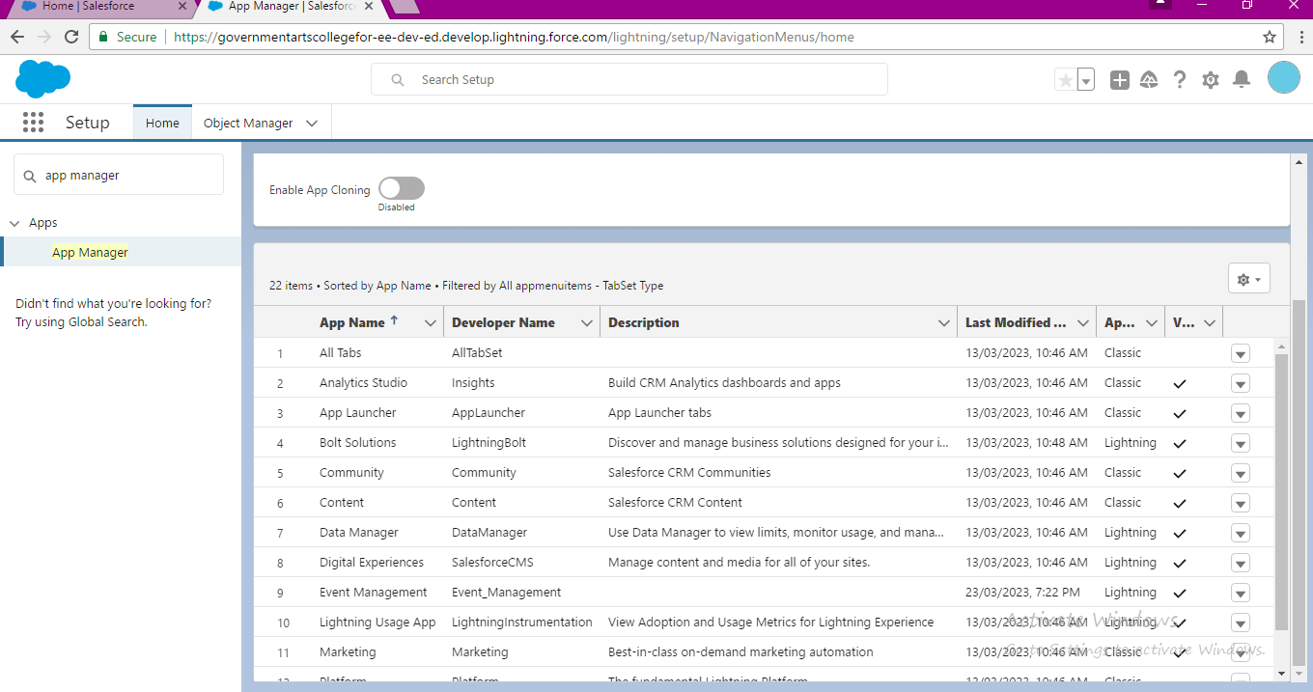

Milestone 4- Fields:

* Click the object management tab next to home.
* Select event.
* Select Field & Relationship from the left navigation.

Event

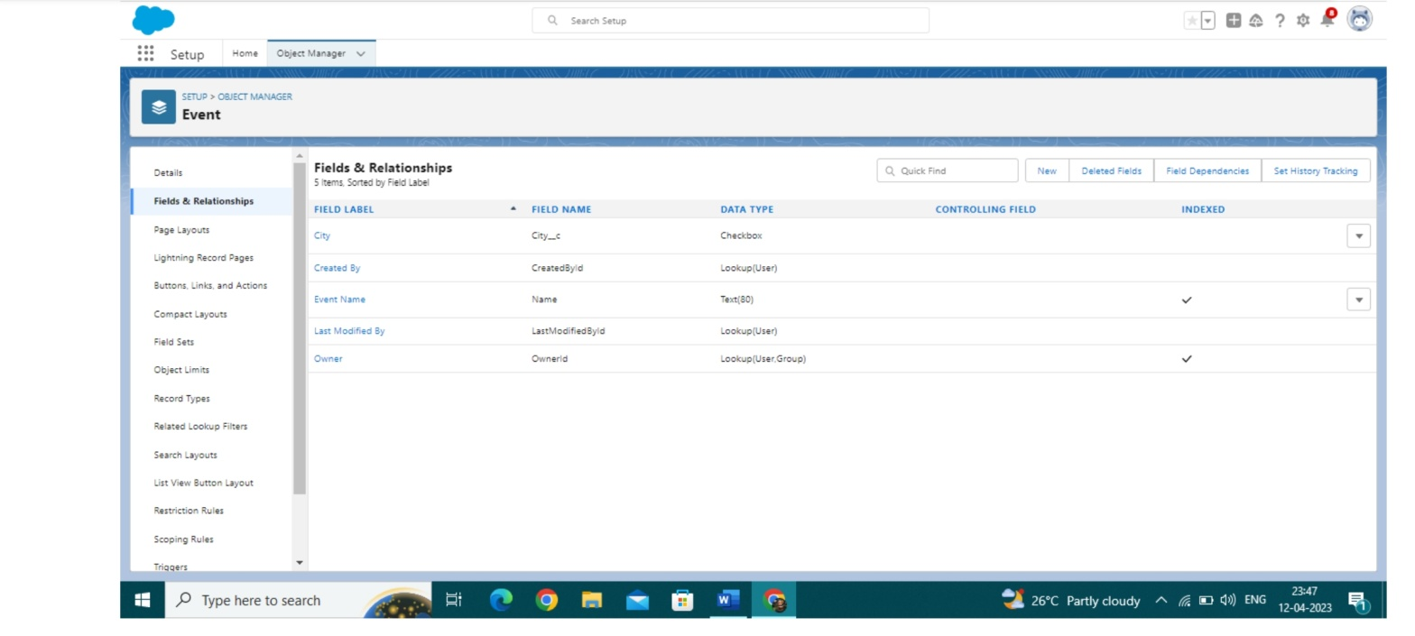

Attendee

* Click the object management tab next to home.
* Select Attendee.
* Select Field & Relationship from the left navigation.

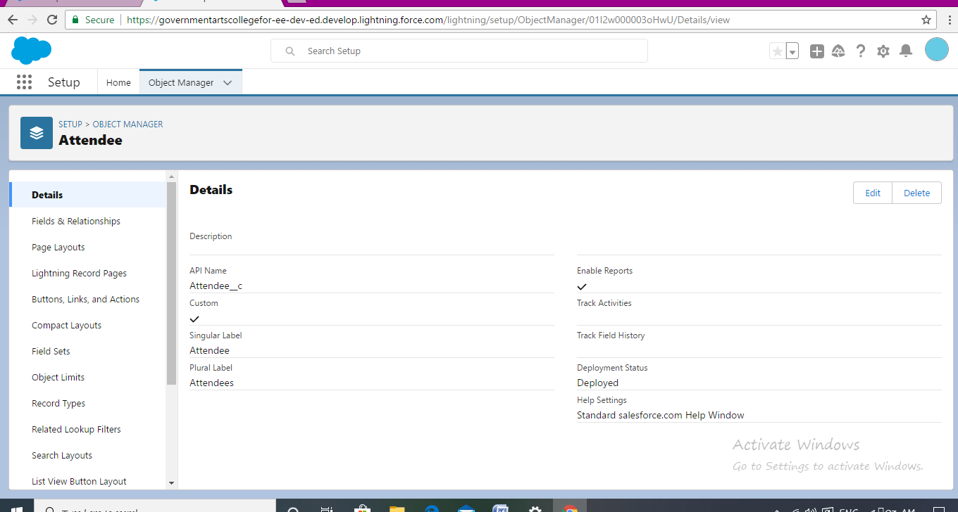

Speaker

* Click the object management tab next to home.
* Select Speaker
* Select Field & Relationship from the left navigation.

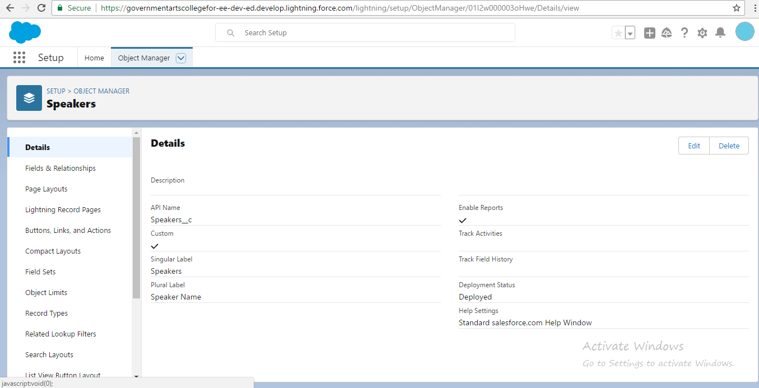

Vendor

* Click the object management tab next to home..
* Select Vendor
* Select Field & Relationship from the left navigation.

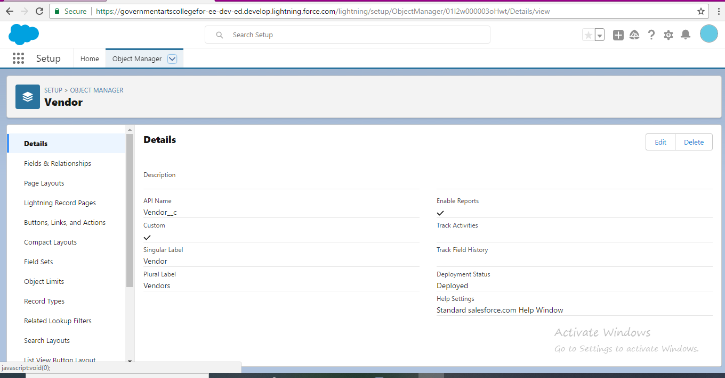

Student

* Click the object management tab next to home.
* Select Student
* Select Field & Relationship from the left navigation.

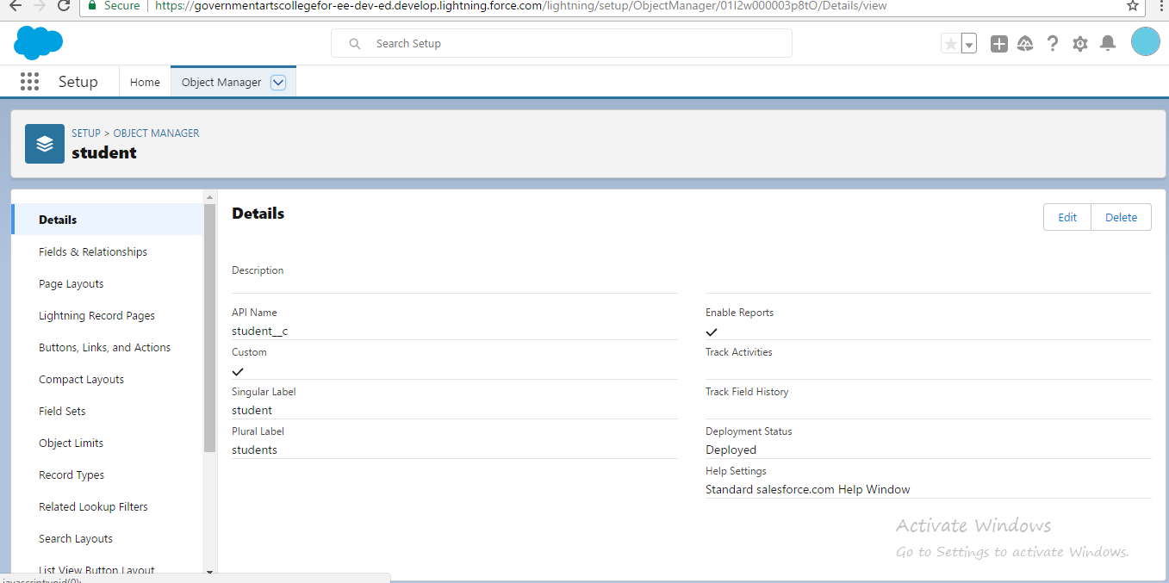

Milestone 5-Profile

* From setup enter, in the Quick find box and select profile.
* Select Standard user click clone
* Enter profile name, Event user profile.
* Click and save.

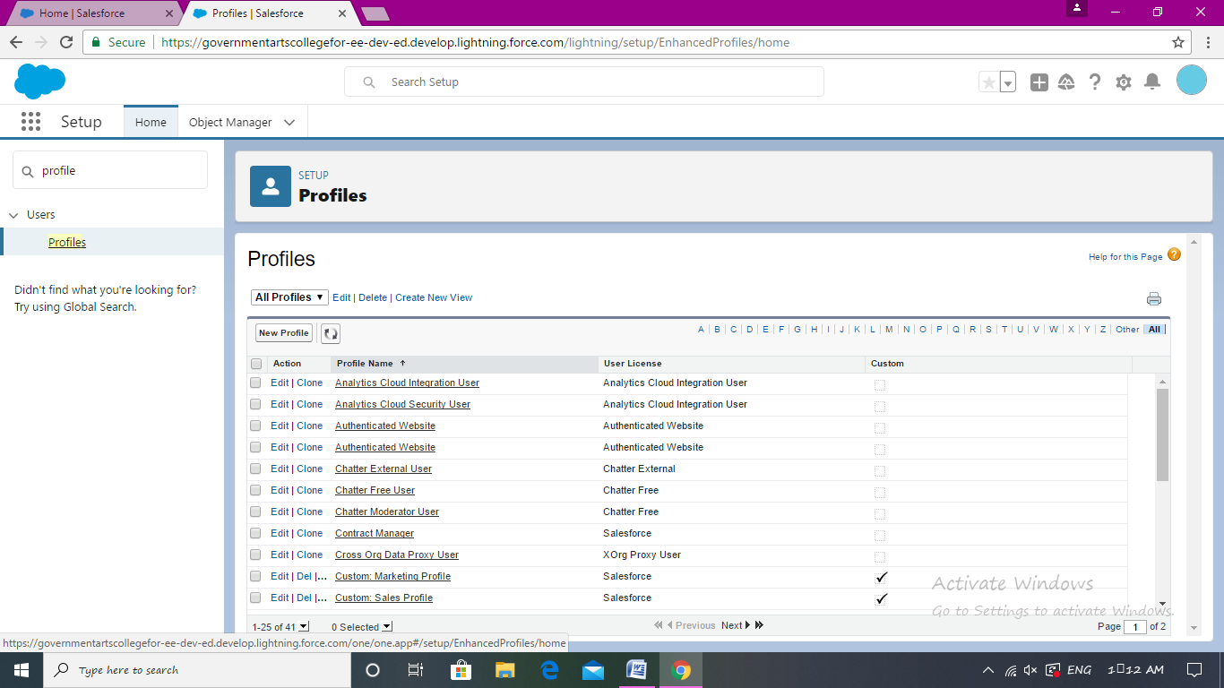

Milestone 6 – User:

* From setup, in the Quick Find box, enter Users.
* Enter the user name and last name, email Id and enter unique user name.
* Enter User profile then click save.

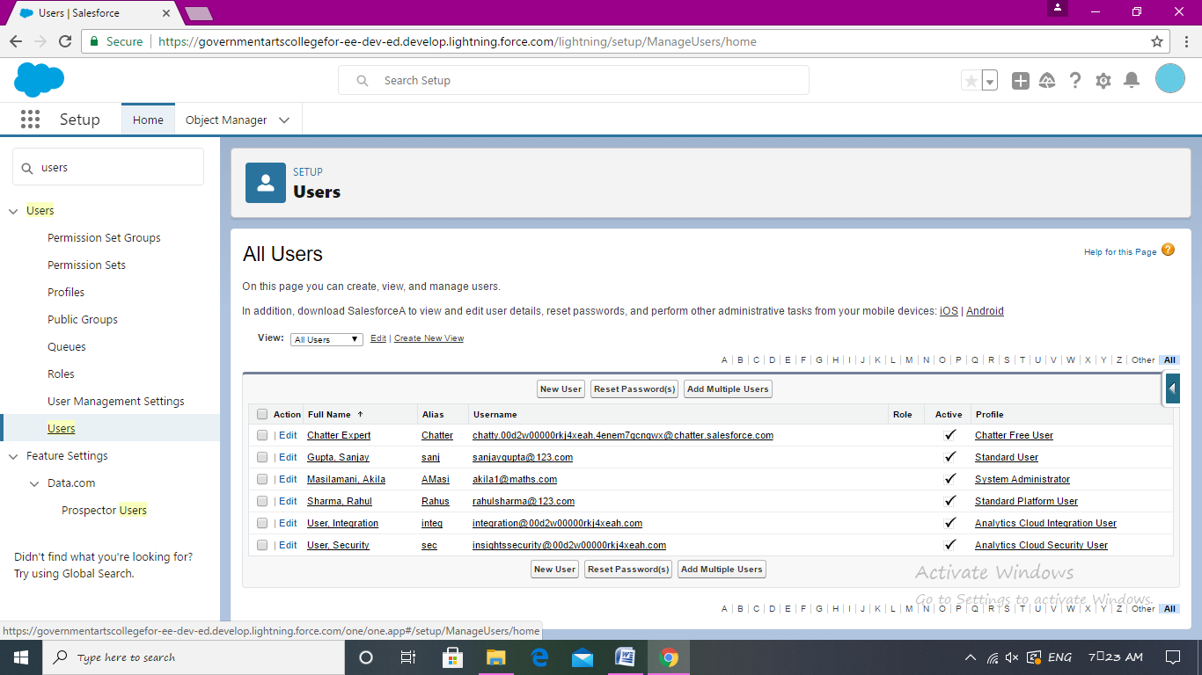

Milestone 7 – Permission sets

* Select permission sets click.
* Enter the Permits
* Select the users and save.

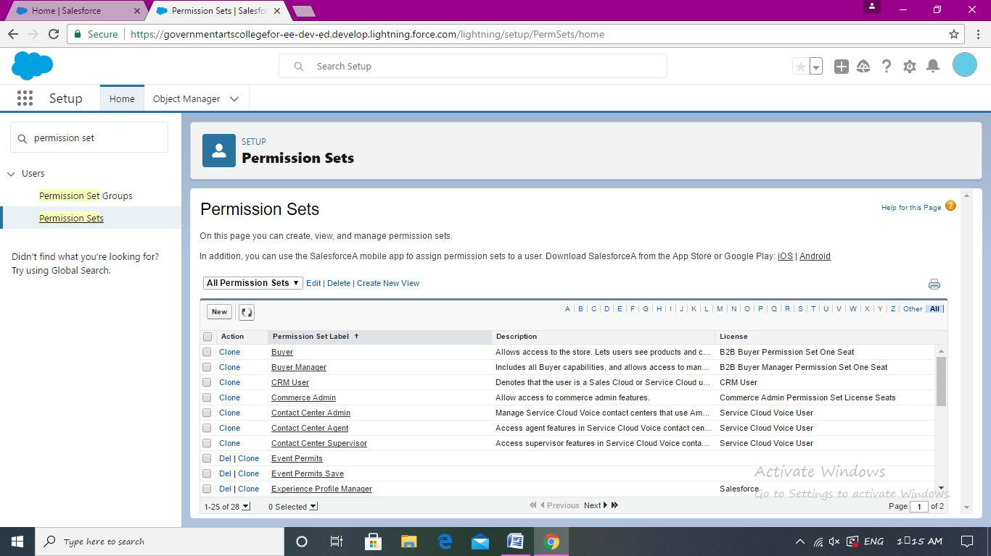

Milestone 8 – Reports

* Click the App Launcher, Search Report and click new report
* Select report type “Attendee with event” and click create.
* Customize your field, then save or run.

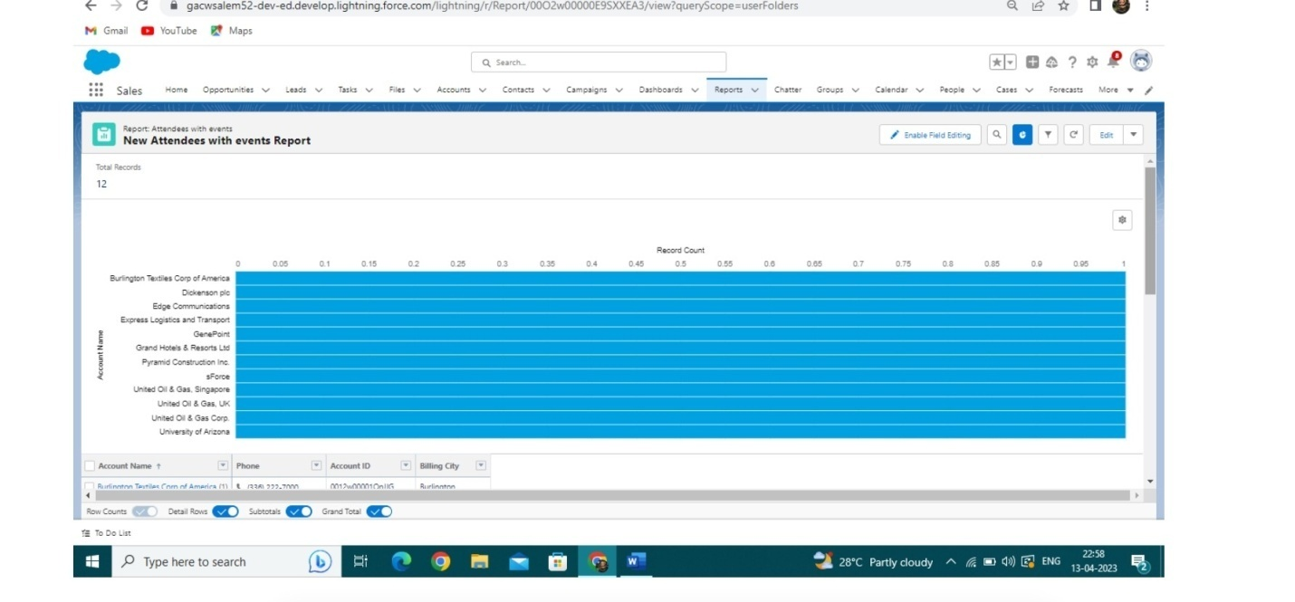

4: Trailhead Profile Public URL

Team Lead: <https://trailblazer.me/id/akilm123>

Team member 1: <https://trailblazer.me/id/ananu103>

Team member 2: <https://trailblazer.me/id/buvam2>

Team member 3: <https://trailblazer.me/id/sownm4>

5. Advantages & Disadvantages

**Advantages:**

* **Efficiently manager Multiple Events.**
* **Smooth execution of planning ideas.**
* **Maintain best account history**
* **Save Time in communication.**
* **Improves competitive strength**

Disadvantage:

* Overall, while an event management system can bring many benefits, organizations should careful consider the potential disadvantage.
* Internal inflexibility, Rapid change. Time consuming process. Securing a venue for the event.
* Finalizing contracts with vendors and performers organizing transportation

**6. Application:**

**The event management system application can help streamline event planning. Improve attendee marriage provide valuable insights for event organizers. Learn from the best professionals and designers to create manage communication new formats.**

7**. Conclusion:**

**This project Improvement of technology to publishing event Increase of publics transport to event. Factors benefit the events industry due to going in to the economy therefore more individuals. In this project extended by introducing new and more innovation features**

**We then explain the concept of online event management system which are already present , we describe the proposed system and explain the features implemented by our proposed system. The technologies used during developments.**

**9. Future Scope:**

**Event management as a career in India is vast. An event management system business and organization plan and events, product launches, post event recap, registration, hotel and travel, such a conferences, trade shows and more.**